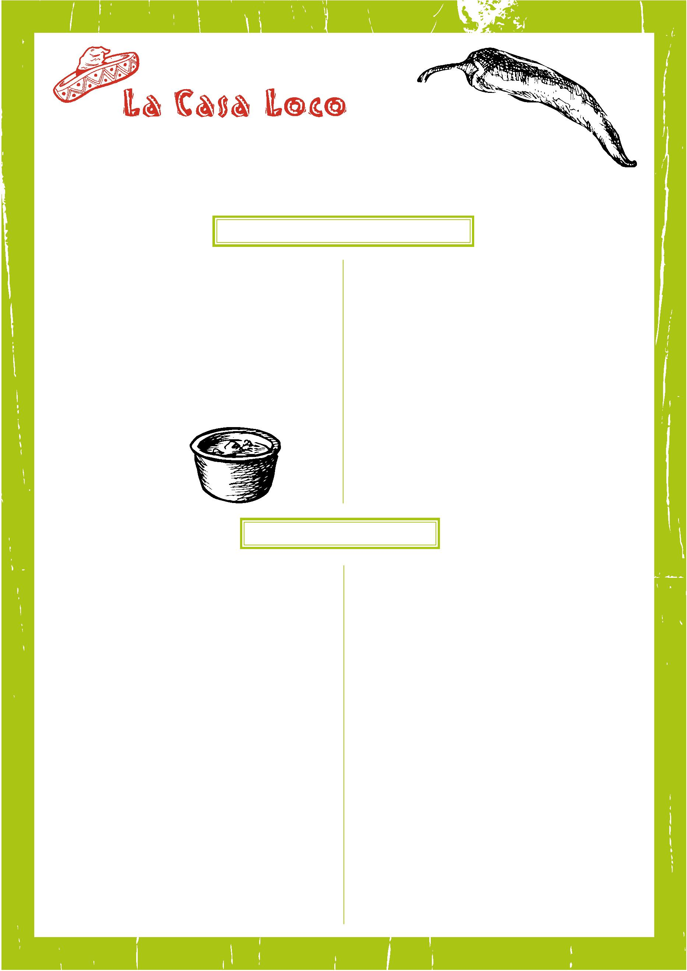
VEGAN MENU
GF – Gluten free option available. Please specify to a member of staff ESPECIALLY IF COELIAC.
Starters
Muchos Nachos GF
A warm plate of tortilla chips smothered in vegan
cheese and served with fresh guacamole, salsa
and jalapenos
£6.65
Quesadillas GF
Two wheat tortillas, ﬁlled with vegan cheese
and toasted on our griddle, served with fresh
guacamole, ﬁlled with your choice of:
cheese, salsa and jalapenos / Jackfruit & toasted cumin
£5.95
Share Nachos GF
Served the same as our muchos nachos but slightly
larger, with the addition of refried black beans
£8.95
Fresh Guacamole
Made to order guacamole, with avocado, onion, chilli,
garlic and tomatoes, served with a dish of tortilla chips.
GF
£4.95
Ultimate Nachos GF
As above but for two or more people with the addition
of vegetarian ratatouille
£10.95
Olives
GF
£3.95
A dish of mixed olives with
rosemary oil and herbs
Main Courses
Authentic Chilli
£12.95
Muchos Burrito OR Burrito Bowl
£13.95
5 bean chilli cooked using traditional herbs and spices, topped with vegan cheese, served on a bed of rice in a crispy tortilla basket, with a side of guacamole.
Muchos Burrito - A large ﬂour tortilla ﬁlled with refried black beans, salad and vegan cheese.
Served with Mexican rice and house salad. Topped with
salsa and fresh guacamole
OR
Enchiladas – Baked and Soft GF
£13.95
Burrito Bowl - Served with rice, salad, Pico
de Gallo, refried black beans, jalapeños, coriander, fresh
guacamole and a wedge of lime.
A large ﬂour tortilla rolled up, topped with vegan cheese and baked. Served with Mexican rice, salad, salsa and guacamole. Filled with your choice of:
5 bean chilli / jackfruit, toasted cumin and refried beans
Choose your ingredients:
Chimichangas – Deep fried and crispy £13.95
A large ﬂour tortilla with vegan cheese, parceled together and deep fried. Topped with salsa and fresh guacamole, served with Mexican rice and house salad.
Stuffed with your choice of:5 beans chilli / jackfruit & toasted cumin
- 5 bean chilli
- jackfruit & toasted cumin
Vegan El Stacko
£14.95
A Mexican style lasagne containing 5 bean chilli, jackfruit & toasted cumin, layered between soft tortillas and
topped with refried beans and vegan cheese. Served with sweet potato fries, salsa and house salad
Sizzling Vegan Fajitas GF
£12.95
Marinated courgette and mixed vegetables, ﬂash fried with bell peppers, onion and garlic. Served sizzling on a cast iron skillet with warm soft tortillas, salsa, fresh guacamole, and vegan cheese
Vegan Tacos GF
£13.95
Soft ﬂour tortillas served with – refried black beans, 5
bean chipotle chilli, rajas (cactus) vegetable ratatouille,
salsa, fresh guacamole, vegan cheese and coleslaw
salad
Soft Tacos GF £5.95
Two soft authentic tortillas filled with slow cooked jackfruit and toasted cumin, refried beans, vegan cheese, shredded salad and pink onion. Topped with coriander, a wedge of lime and served with a side of guacamole

CHILDREN’S MENU
Suitable for up to age 10 Tiny Tots up to age 3
Please specify any dietary requirements
Starters – all at £2.50
Muchos Nachos GF V VG
Calamari
Warm tortilla chips smothered in melting cheese and
served with dollops of sour cream, guacamole and
salsa
Lightly dusted then deep fried, served with a lime
mayonnaise dip
Crudites GF
Your choice of carrot sticks, cucumber sticks or tortilla chips, served with our homemade fresh guacamole

Cheesy Garlic Bread V
Garlic Bread V
Cheesy Wedges V

Quesadillas GF V VG
A ﬂour tortilla, ﬁlled with cheese, homemade
tomato sauce and toasted on our griddle served
with sour cream
Potato Skin V
Deep fried potato skin ﬁlled with cheese and
served with sour cream
Main Course – all at £4.95 (**tiny tot portions at £2.95)
Baby Enchiladas ** GF V VG
Breaded Chicken Strips
A ﬂour tortilla with your choice of chilli beef, spicy
chicken or 5 bean chilli, baked in our oven and
topped with cheese and sour cream. Served with Mexican rice, vegetables and sour cream
Fresh chicken filets flattened, and coated with breadcrumbs then deep fried Served with vegetables and chips

Spaghetti Bolognese **
Spaghetti with our homemade minced beef Bolognese, topped with a sprinkling of cheese

Hickory Smoked ½ Rack of Ribs (£2 supplement)
Our famous pork ribs cooked in our homemade barbeque sauce, served with deep fried potato wedges

Kids Fish Tacos
Battered jumbo fish fingers with cod fillet. Served with chips, ketchup, two soft tortillas and salad

Chicken Fajitas ** GF
Chicken strips ﬂash fried with bell peppers,
onion and garlic. Served with two warm tortillas.
Accompanied by guacamole, sour cream, salsa and grated cheese
Steak Burger
A 4oz Onley Grounds 100% beef steak burger
char-grilled then served with or without cheese and
ketchup and wrapped in a lightly toasted soft tortilla
with chips.
Pizza and Chips VVG
6” Mexican pizza, two tortillas pressed together and
topped with homemade tomato sauce, chorizo and
mozzarella. Baked until golden and served with chips
and salad
Sample dessert menu £2.50 (may change on the day)
Cheesecake of the Day GF
Selection of Ice Cream
Choose two scoops of the following:
vanilla – caramel honeycomb – mint choc chip –
white chocolate chip – sea salted caramel
Homemade Chocolate Brownie GF
Served with ice cream
Lasagne Our homemade Bolognese layered between sheets of lasagne pasta, bechamel and cheese. Baked in our oven and served with chips and vegetables

